TASK 02
#include <iostream>
using namespace std;

#define capacity 100

class MaxHeap {
public:
int heap[capacity];
int size;

MaxHeap() : size(0) {}

int parent(int i) {return (i - 1)/2;}
int leftChild(int i) {return 2*i + 1;}
int rightChild(int i) {return 2*i + 2;}

void maxHeapify(int i) {
int largest = i;
int left = leftChild(i);
int right = rightChild(i);

if (left < size && heap[left] > heap[largest]) {
largest = left;
}
if (right < size && heap[right] > heap[largest]) {
largest = right;
}

if (largest != i) {
swap(heap[i], heap[largest]);
maxHeapify(largest);
}
}

void insert(int value) {
if (size == capacity) {
cout << "Heap is full!!" << endl;
return;
}

cout << "Inserting value: " << value << endl;

heap[size] = value;
size++;

int i = size - 1;
while (i != 0 && heap[parent(i)] < heap[i]) {
swap(heap[i], heap[parent(i)]);
i = parent(i);
}
printHeap();
}

void removeRoot() {
if (size <= 0) {
cout << "Heap is empty!!" << endl;
return;
}
if (size == 1) {
size--;
return;
}
heap[0] = heap[size - 1];
size--;

maxHeapify(0);
}

void printHeap() {
cout << "Heap elements: ";
for (int i = 0; i < size; i++) {
cout << heap[i] << " ";
}
cout << endl;
}

};

int main() {
MaxHeap pq;

pq.insert(50);
pq.insert(30);
pq.insert(20);
pq.insert(15);
pq.insert(10);
pq.insert(8);
pq.insert(16);

cout << "Removing root (highest priority)..." << endl;
pq.removeRoot();

pq.printHeap();

return 0;
}

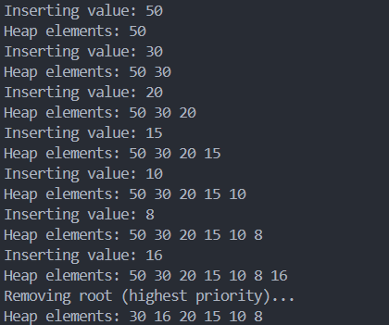

TASK 05
#include <iostream>
using namespace std;

#define capacity 100

class MaxHeap {
public:
int heap[capacity];
int size;

MaxHeap() : size(0) {}

int parent(int i) {return (i - 1)/2;}
int leftChild(int i) {return 2*i + 1;}
int rightChild(int i) {return 2*i + 2;}

void maxHeapify(int i) {
int largest = i;
int left = leftChild(i);
int right = rightChild(i);

if (left < size && heap[left] > heap[largest]) {
largest = left;
}
if (right < size && heap[right] > heap[largest]) {
largest = right;
}

if (largest != i) {
swap(heap[i], heap[largest]);
maxHeapify(largest);
}
}

void insert(int value) {
if (size == capacity) {
cout << "Heap is full!!" << endl;
return;
}

cout << "Inserting value: " << value << endl;

heap[size] = value;
size++;

int i = size - 1;
while (i != 0 && heap[parent(i)] < heap[i]) {
swap(heap[i], heap[parent(i)]);
i = parent(i);
}
printHeap();
}

void removeMax() {
if (size <= 0) {
cout << "Heap is empty!!" << endl;
return;
}
if (size == 1) {
size--;
return;
}
heap[0] = heap[size - 1];
size--;

maxHeapify(0);
}

void updatePriority(int i, int newPriority) {
if (i < 0 || i >= size) {
cout << "Invalid index!" << endl;
return;
}
int oldPriority = heap[i];
heap[i] = newPriority;
if (newPriority > oldPriority) {
while (i != 0 && heap[parent(i)] < heap[i]) {
swap(heap[i], heap[parent(i)]);
i = parent(i);
}
} else if (newPriority < oldPriority) {
maxHeapify(i);
}
printHeap();
}

void printHeap() {
cout << "Heap elements: ";
for (int i = 0; i < size; i++) {
cout << heap[i] << " ";
}
cout << endl;
}

};

int main() {

MaxHeap pq;

pq.insert(40);
pq.insert(20);
pq.insert(60);
pq.insert(10);
pq.insert(50);

cout << "Processing (removing) highest priority task..." << endl;
pq.removeMax();
pq.printHeap();

cout << "Updating priority of task at index 2 to 70..." << endl;
pq.updatePriority(2, 70);

cout << "Updating priority of task at index 1 to 5..." << endl;
pq.updatePriority(1, 5);

cout << "Final heap:" << endl;
pq.printHeap();

return 0;
}

